**Jakeman Nursery School Room Hire Charges and Booking Form**

If you would like to make a general enquiry first, please email [enquiry@jakeman.bham.sch.uk](mailto:enquiry@jakeman.bham.sch.uk)

**Details of person booking the room**

|  |  |
| --- | --- |
| **Name** |  |
| **Role** |  |
| **Organisation and Organisation Address** |  |
| **Contact Number** |  |
| **Email Address** |  |
| **Date of Event** |  |
| **Title Of Meeting/Training/Visit** |  |
| **Name of Trainer/Presenter/Visit Leader** |  |

**Cancellation Policy**

|  |  |
| --- | --- |
| **Cancellation received less than 48 hours prior to booking date** | **100% of Total Fee** |
| **Cancellation received in writing less than 5 working days prior to booking date** | **50% of Total Fee** |
| **Cancellation received in writing 10 working days prior to booking date** | **No Charge** |

**Special Provisions/requirements**

|  |  |
| --- | --- |
| **Details** |  |

**Large Meeting/Training Room Layout Choices**

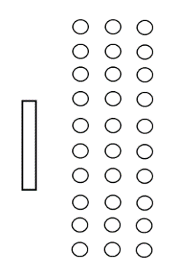

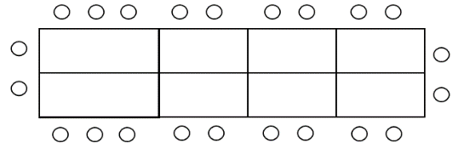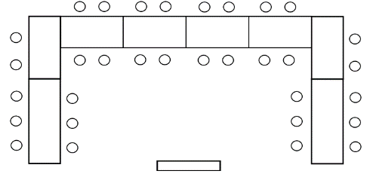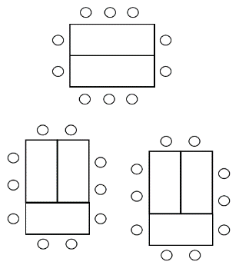

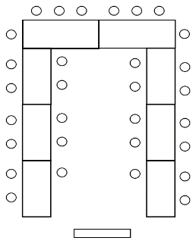

Horseshoe 2

Theatre

Horseshoe 1

Boardroom

Banquet

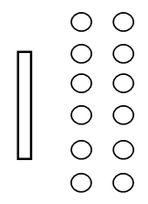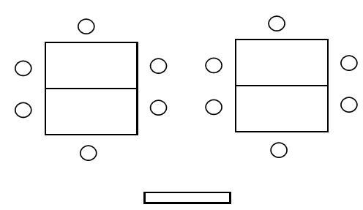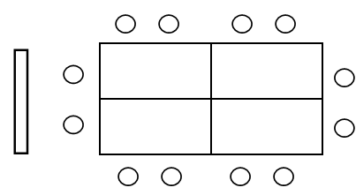**Small Meeting/Training Room Layout Choices**

Theatre

Banquet

Boardroom

**Additional information:**

* ***Parking in the Jakeman carpark is first come, first served***
* ***There is parking on residential streets close to the Nursery***
* ***Training room is located in the 2 storey-building, on the left hand side of the carpark***
* ***All attendees must sign in and out with the facilitator/organisation***
* ***Mobile phone use is not permitted on the ground floor of the building***
* ***Please refer to Fire Evacuation Procedures shared at point of booking confirmation. The facilitator shares this information with attendees.***
* ***The training/meeting room is located on the first floor. Please note, the lift is currently out of use.***
* ***Toilet facilities are available on both ground and first floors.***
* ***Should any of the attendees have any concerns of a child protection or safeguarding nature, please ask at reception in the main nursery building for the DSL on duty.***

|  |  |  |  |  |  |
| --- | --- | --- | --- | --- | --- |
| **ROOM** | **ROOM**  **CAPACITY** | **Charges** | **Select:**  **Full day/ AM/ PM /**  **# of hours** | **Room Set up:**  **(Please highlight or tick)** | **Date(s) Required:** |
| **Large Training Room**  (Interactive screen) | 30 | £150 per full day**  £80 per half day*  £25 per hour |  | Boardroom  Banquet  Horseshoe 1  Horseshoe 2  Theatre  Other: |  |
| **Small Training Room**  (NoInteractive Screen) | 10 | £80 per full day**  £45 per half day*  £15 per hour |  | Boardroom  Banquet  Theatre  Other: |  |

*HALF DAY BOOKING - 8AM-12NOON OR 12:30PM -4:30PM ** FULL DAY BOOKING - 8AM-4:30PM

**Invoice to be sent to:**

|  |  |
| --- | --- |
| **Name** |  |
| **Role** |  |
| **Address** |  |
| **Contact Number** |  |
| **Email Address** |  |
| **Total Cost** |  |
| **Purchase Order Number** |  |
| **Invoice Sent date & by whom** |  |
| **Payment Received by & date** |  |
| **ALL BOOKING FORMS TO BE EMAILED TO AMNA BIBI – a.bibi@jakeman.bham.sch.uk** | |